MACH4METAL

Metalworking machinery
Transito 21,
6909 DA BABBERICH
Netherlands
Tel. +31 (0)316 – 247123
Fax. +31 (0)316 - 247956
info@mach4metal.com
www.mach4metal.com

Account No: 66.52.13.883
IBAN : NL33 INGB 0665 2138 83
BIC : INGBNL2A

IXION Deep hole drilling machine

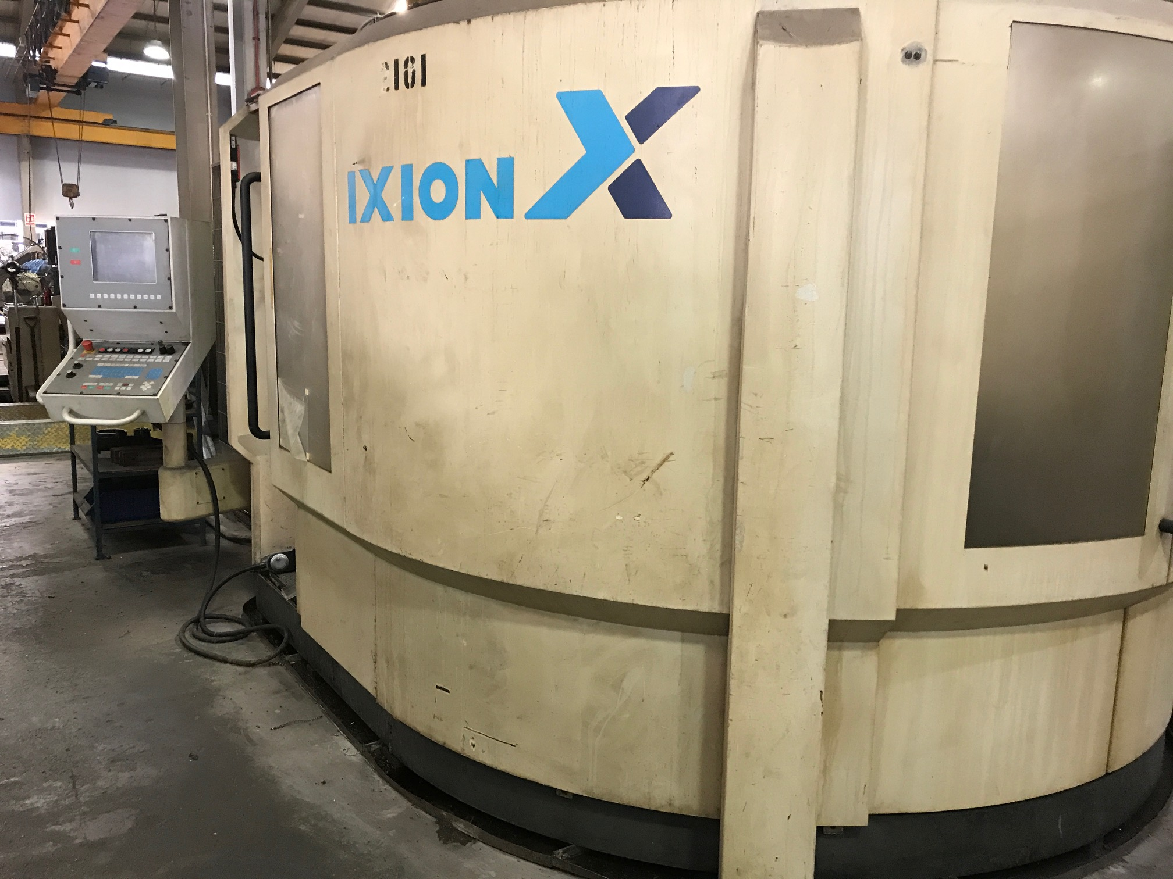
- Make : IXION Auerbach Germany
- Typ : TL 1004
- Mach. No : 95. 05 . 25
- Age : 2009

- Capacity
- X : 1000
- Y : 400
- Z : 1000
- W : 1100
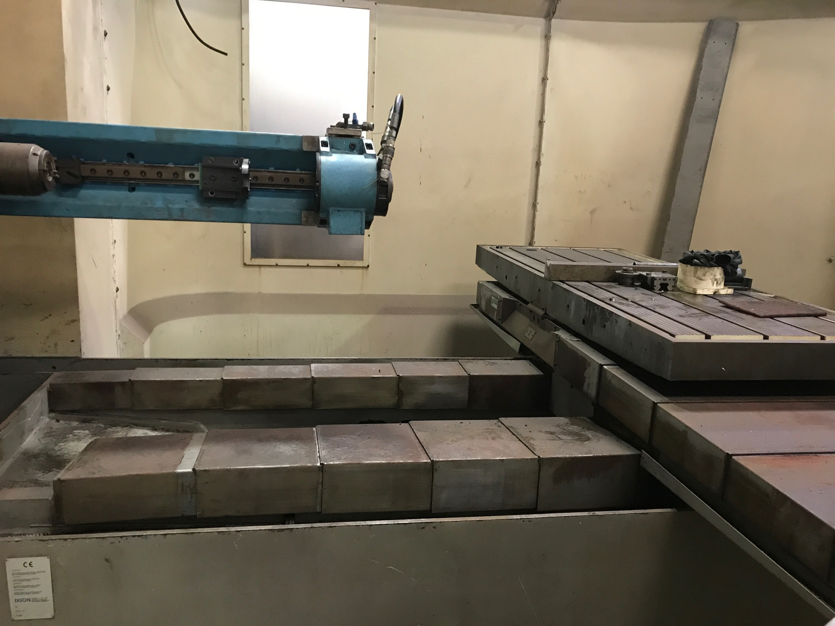

- Table length : 1.675
- Table width : 700
- Rotation : 360
- Load : 3000

- Drilling capacity : Ø 6 – 32 mm
- Spindle : ISO 40
- Spindle speeds : 0 – 4.000 Rpm.
- Power : 7.5 KW
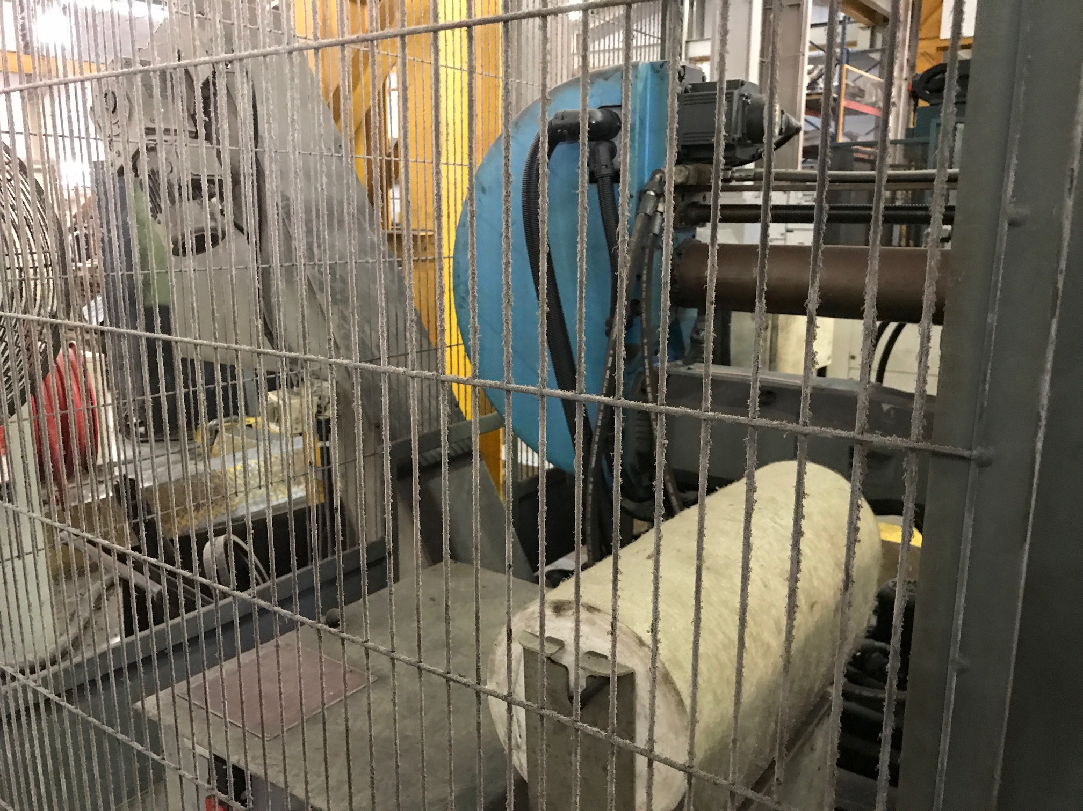

- Dimensions

- Length : 4000
- Width : 6600
- Height : 2300

- Internal coolant 100 Bar
- Filtration system
- Mitsubishi MELDAS 4 Axis CNC

Please Note: The above information has been obtained to the best of our ability and belief from, and from the manufacturers where possible. It is given in good faith, but its accuracy can not be guaranteed. Accordingly, it will not form a representation or constitute contractual terms. We advise you to check any vital details!

